**Introduction**

Imagine one of your colleagues is struggling with a program that keeps throwing an error. Unfortunately, the program's source code is too complicated to easily find the error there. The good news is that the program outputs a log file you can read! Let's write a script to search the log file for the exact error, then output that error into a separate file so you can work out what's wrong.

**What you'll do**

* Write a script to search the log file using regex to find for the exact error.
* Report the error into a separate file so you know what's wrong for further analysis.

You'll have 90 minutes to complete this lab.

Start the lab

You'll need to start the lab before you can access the materials in the virtual machine OS. To do this, click the green “Start Lab” button at the top of the screen.

**Note:** For this lab you are going to access the **Linux VM** through your **local SSH Client**, and not use the **Google Console** (**Open GCP Console** button is not available for this lab).

After you click the “Start Lab” button, you will see all the SSH connection details on the left-hand side of your screen. You should have a screen that looks like this:

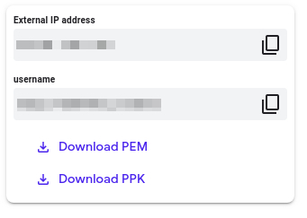

**Accessing the virtual machine**

Please find one of the three relevant options below based on your device's operating system.

**Note:** Working with Qwiklabs may be similar to the work you'd perform as an **IT Support Specialist**; you'll be interfacing with a cutting-edge technology that requires multiple steps to access, and perhaps healthy doses of patience and persistence(!). You'll also be using **SSH** to enter the labs -- a critical skill in IT Support that you’ll be able to practice through the labs.

Option 1: Windows Users: Connecting to your VM

In this section, you will use the PuTTY Secure Shell (SSH) client and your VM’s External IP address to connect.

**Download your PPK key file**

You can download the VM’s private key file in the PuTTY-compatible **PPK** format from the Qwiklabs Start Lab page. Click on **Download PPK**.



**Connect to your VM using SSH and PuTTY**

1. You can download Putty from [here](https://the.earth.li/~sgtatham/putty/latest/w64/putty.exe)
2. In the **Host Name (or IP address)** box, enter username@external_ip_address.

**Note:** Replace **username** and **external_ip_address** with values provided in the lab.



1. In the **Category** list, expand **SSH**.
2. Click **Auth** (don’t expand it).
3. In the **Private key file for authentication** box, browse to the PPK file that you downloaded and double-click it.
4. Click on the **Open** button.

**Note:** PPK file is to be imported into PuTTY tool using the Browse option available in it. It should not be opened directly but only to be used in PuTTY.



1. Click **Yes** when prompted to allow a first connection to this remote SSH server. Because you are using a key pair for authentication, you will not be prompted for a password.

**Common issues**

If PuTTY fails to connect to your Linux VM, verify that:

* You entered **<username>**@**<external ip address>** in PuTTY.
* You downloaded the fresh new PPK file for this lab from Qwiklabs.
* You are using the downloaded PPK file in PuTTY.

Option 2: OSX and Linux users: Connecting to your VM via SSH

**Download your VM’s private key file.**

You can download the private key file in PEM format from the Qwiklabs Start Lab page. Click on **Download PEM**.



**Connect to the VM using the local Terminal application**

A **terminal** is a program which provides a **text-based interface for typing commands**. Here you will use your terminal as an SSH client to connect with lab provided Linux VM.

1. Open the Terminal application.
   * To open the terminal in Linux use the shortcut key **Ctrl+Alt+t**.
   * To open terminal in **Mac** (OSX) enter **cmd + space** and search for **terminal**.
2. Enter the following commands.

**Note:** Substitute the **path/filename for the PEM** file you downloaded, **username** and **External IP Address**.

You will most likely find the PEM file in **Downloads**. If you have not changed the download settings of your system, then the path of the PEM key will be **~/Downloads/qwikLABS-XXXXX.pem**

chmod 600 ~/Downloads/qwikLABS-XXXXX.pem

ssh -i ~/Downloads/qwikLABS-XXXXX.pem username@External Ip Address

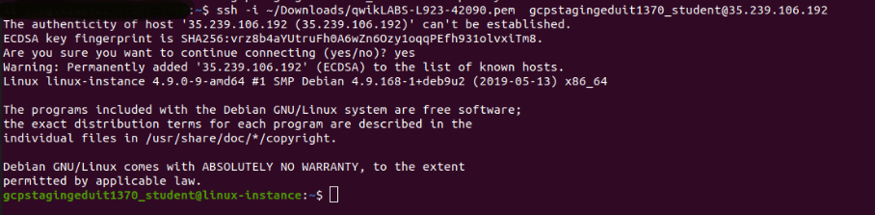

Option 3: Chrome OS users: Connecting to your VM via SSH

**Note:** Make sure you are not in **Incognito/Private mode** while launching the application.

**Download your VM’s private key file.**

You can download the private key file in PEM format from the Qwiklabs Start Lab page. Click on **Download PEM**.



**Connect to your VM**

1. Add Secure Shell from [here](https://chrome.google.com/webstore/detail/secure-shell-app/pnhechapfaindjhompbnflcldabbghjo) to your Chrome browser.
2. Open the Secure Shell app and click on **[New Connection]**.

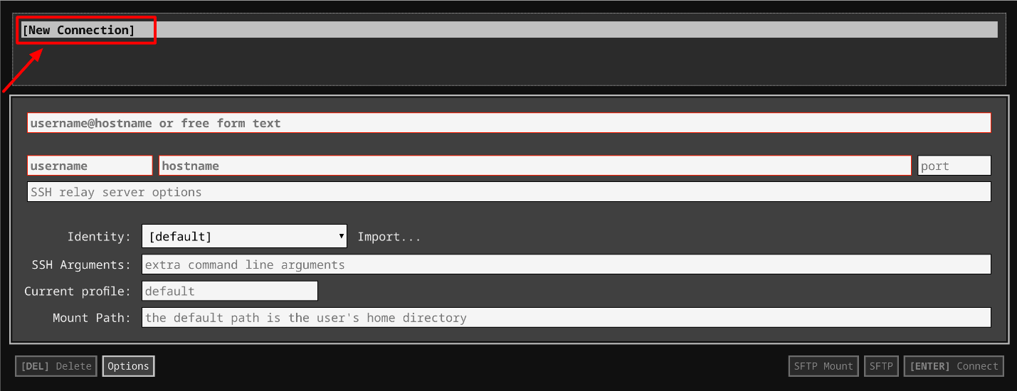

1. In the **username** section, enter the username given in the Connection Details Panel of the lab. And for the **hostname** section, enter the external IP of your VM instance that is mentioned in the Connection Details Panel of the lab.

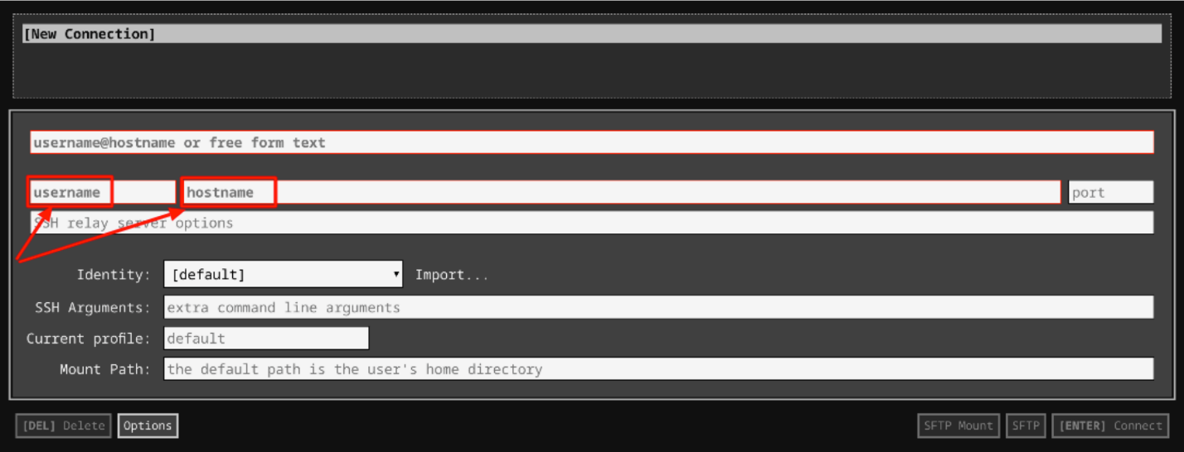

1. In the **Identity** section, import the downloaded PEM key by clicking on the **Import…** button beside the field. Choose your PEM key and click on the **OPEN** button.

**Note:** If the key is still not available after importing it, refresh the application, and select it from the **Identity** drop-down menu.

1. Once your key is uploaded, click on the **[ENTER] Connect** button below.

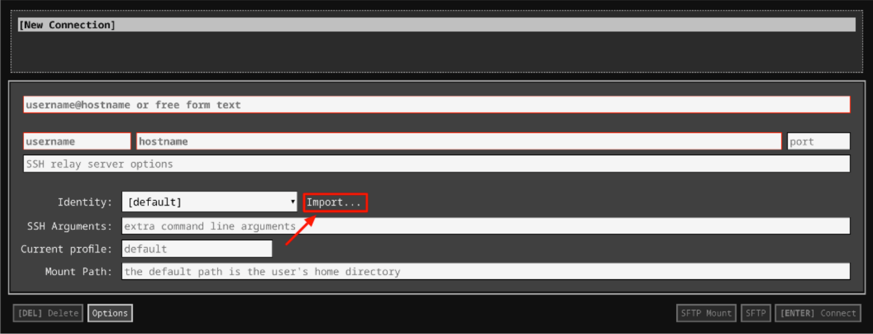

1. For any prompts, type **yes** to continue.
2. You have now successfully connected to your Linux VM.

You're now ready to continue with the lab!

**View log file**

In the /data directory, there's a file named fishy.log, which contains the system log. Log entries are written in this format:

Month Day hour:minute:second mycomputername "process_name"["random 5 digit number"] "ERROR/INFO/WARN" "Error description"

For every process, the runtime log that's generated contains a timestamp and appropriate message alongside. You can view all logs using the command below:

cat ~/data/fishy.log

Output:

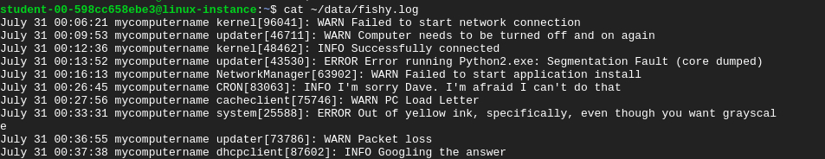

**Find an error**

In this lab, we'll search for the CRON error that failed to start. To do this, we'll use a python script to search log files for a particular type of ERROR log. In this case, we'll search for a CRON error within the fishy.log file that failed to start by narrowing our search to "CRON ERROR Failed to start".

To get started, let's create a python script named **find_error.py** within scripts directory using nano editor.

cd ~/scripts

nano find_error.py

Add the shebang line:

#!/usr/bin/env python3

Import the necessary Python modules:

import sys

import os

import re

The **sys** module provides information about the Python interpreter's constants, functions, and methods. The **os** module provides a portable way of using operating system dependent functionality with Python.

Regular Expression (RegEx) is a sequence of characters that defines a search pattern. We can use regular expressions using **re** module.

Now, write a function error_search that takes log_file as a parameter and returns returned_errors. Define the error_search function and pass the log file to it as a parameter.

def error_search(log_file):

To allow us to search all log files for any type of logs, we'll be making our script consistent and dynamic.

Define an input function to receive the type of ERROR that the end-user would like to search and assign to a variable named error.

The input() function takes the input from the user and then evaluates the expression. This means Python automatically identifies whether the user entered a string, a number, or a list. If the input provided isn't correct then Python will raise either a syntax error or exception. The program flow will stop until the user has given an input.

Later in the script, we'll iterate over this user input and the log file to produce results. Following the input function, now initialize the list returned_errors. This will enlist all the ERROR logs as specified by the end-user through the input function.

error = input("What is the error? ")

returned_errors = []

Use the Python file's handling methods to open the log file in reading mode and use 'UTF-8' encoding.

with open(log_file, mode='r',encoding='UTF-8') as file:

We'll now read each log separately from the fishy.log file using the readlines() method. As mentioned earlier, we'll iterate over user input to get the desired search results. For this, we'll create a list to store all the patterns (user input) that will be searched. This list is named error_patterns and, initially it has a pattern "**error**" to filter out all the ERROR logs only. You can change this to view other types of logs such as INFO and WARN. You can also empty initialize the list to fetch all types of logs, irrespective of their type.

We'll add the whole user input to this list error_patterns.

for log in file.readlines():

error_patterns = ["error"]

for i in range(len(error.split(' '))):

error_patterns.append(r"{}".format(error.split(' ')[i].lower()))

Now, let's use the search() method (present in re module) to check whether the file fishy.log has the user defined pattern and, if it is available, append them to the list returned_errors.

if all(re.search(error_pattern, log.lower()) for error_pattern in error_patterns):

returned_errors.append(log)

Next, close the file fishy.log and return the results stored in the list returned_errors.

file.close()

return returned_errors

Great job! You've successfully defined a function to store all the logs defined as a CRON error that fails to start. In the next section, we'll generate a new file consisting of the logs based on your search within /data directory.

**Create an output file**

Let's define another function file_output that takes returned_errors, returned by a previous function, as a formal parameter.

def file_output(returned_errors):

Using Python file handling methods, write returned_errors into the errors_found.log file by opening the file in writing mode. For defining the output file, we'll use the method os.path.expanduser ('~'), which returns the home directory of your system instance. Then, we'll concatenate this path (to the home directory) to the file errors_found.log in /data directory.

with open(os.path.expanduser('~') + '/data/errors_found.log', 'w') as file:

Next, write all the logs to the output file by iterating over returned_errors.

for error in returned_errors:

file.write(error)

And finally, close the file.

file.close()

**Function call**

Now, let's call the functions and run the script.

Define the main function and call both functions that we defined in the earlier sections.

The variable log_file takes in the path to the log file passed as a parameter. In our case, the file is fishy.log. Call the first function i.e., error_search() and pass the variable log_file to the function. This function will search and return a list of errors that would be stored in the variable returned_errors. Call the second function file_output and pass the variable returned_errors as a parameter.

sys.exit(0) is used to exit from Python, the optional argument passed can be an integer giving the exit status (defaulting to zero), or another type of object. If it is an integer, zero is considered "successful termination" and any nonzero value is considered an "abnormal termination" by shells.

if __name__ == "__main__":

log_file = sys.argv[1]

returned_errors = error_search(log_file)

file_output(returned_errors)

sys.exit(0)

The complete file find_error.py should now look like this:

#!/usr/bin/env python3

import sys

import os

import re

def error_search(log_file):

error = input("What is the error? ")

returned_errors = []

with open(log_file, mode='r',encoding='UTF-8') as file:

for log in file.readlines():

error_patterns = ["error"]

for i in range(len(error.split(' '))):

error_patterns.append(r"{}".format(error.split(' ')[i].lower()))

if all(re.search(error_pattern, log.lower()) for error_pattern in error_patterns):

returned_errors.append(log)

file.close()

return returned_errors

def file_output(returned_errors):

with open(os.path.expanduser('~') + '/data/errors_found.log', 'w') as file:

for error in returned_errors:

file.write(error)

file.close()

if __name__ == "__main__":

log_file = sys.argv[1]

returned_errors = error_search(log_file)

file_output(returned_errors)

sys.exit(0)

Save the file by clicking Ctrl-o, followed by the Enter key and Ctrl-x.

Make the file executable before running it.

sudo chmod +x find_error.py

Now, run the file by passing the path to fishy.log as a parameter to the script.

./find_error.py ~/data/fishy.log

This script will now prompt for the type of error to be searched. Continue by entering the following type of error:

CRON ERROR Failed to start

On successful execution, this will generate an **errors_found.log** file, where you will find all the ERROR logs based on your search. You can view the ERROR log using the command below:

cat ~/data/errors_found.log

This will output the following:



Click *Check my progress* to verify the objective.

Generate a file consisting of required error

Check my progress

**Congratulations!**

Congrats! You've written a script to search the log file for the exact error, and then output that error into a separate file for further analysis. As an IT specialist, this tool will be super helpful, allowing you to use Python scripting to filter out and analyze all types of logs.

**End your lab**

When you have completed your lab, click **End Lab**. Qwiklabs removes the resources you’ve used and cleans the account for you.

You will be given an opportunity to rate the lab experience. Select the applicable number of stars, type a comment, and then click **Submit**.

The number of stars indicates the following:

* 1 star = Very dissatisfied
* 2 stars = Dissatisfied
* 3 stars = Neutral
* 4 stars = Satisfied
* 5 stars = Very satisfied

You can close the dialog box if you don't want to provide feedback.

For feedback, suggestions, or corrections, please use the **Support** tab.